The Vanishing Quarter — An OLAP Investigation

Name: Mithunjai. E
Roll number: 24BAD071

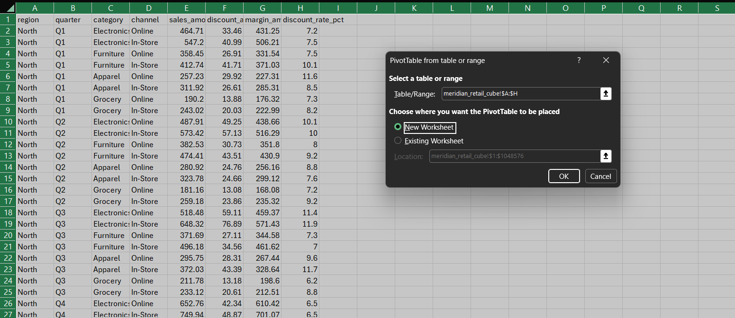
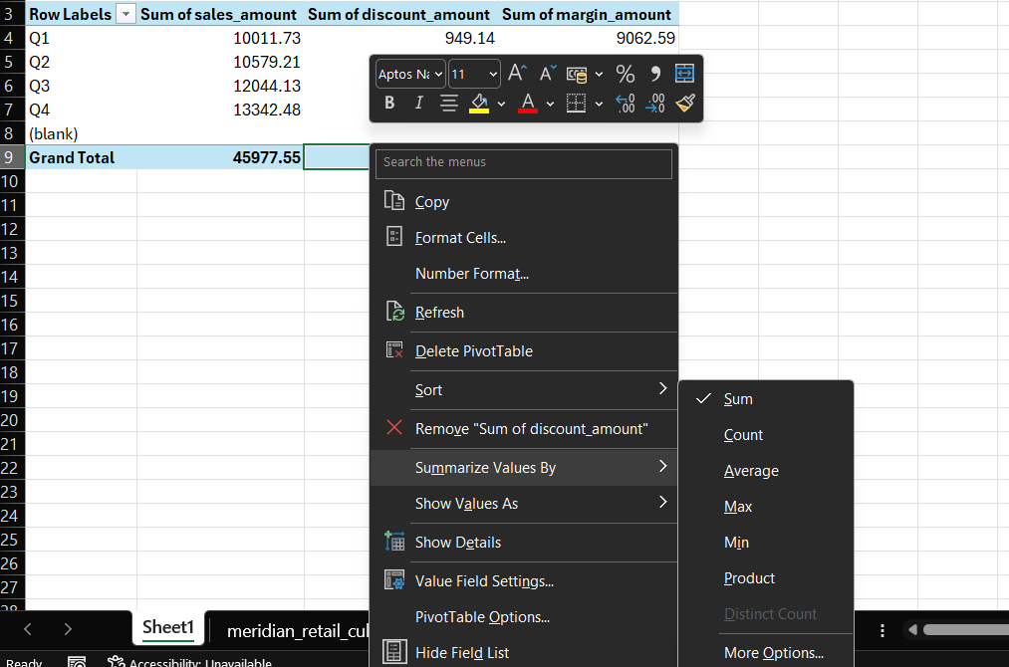

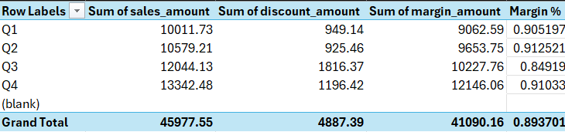

Q3 is absolutely the margin problem.
- Q3 has the third-highest sales in the table you pasted, not the highest overall — Q4 is higher at 13,342.48.
- But Q3's margin % is only 84.92%, versus roughly 90–91% in the other quarters.
- Q3's discount amount is 1,816.37, dramatically higher than Q1 (949.14), Q2 (925.46), and Q4 (1,196.42).
That's a very strong signal that discounting is driving the margin collapse.
Case-file note:
Roll-up to quarter level identified Q3 as the margin outlier: 12,044.13 sales, 1,816.37 discounts, 10,227.76 margin, and only 84.92% margin.

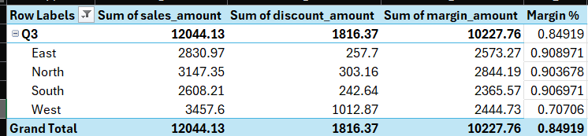

West is massively different from the other regions.
Its margin rate is only 70.71%, compared with approximately 90–91% everywhere else.
Even more telling:
- West sales = 3,457.60, about 29% of Q3 sales.
- West discounts = 1,012.87, about 56% of ALL Q3 discounts.
- West margin = 2,444.73.
OLAP operation
Slicing the cube to Q3, then compared the regional dimensions.
Case-file entry
View 2 — Q3 regional slice: After slicing to Q3, West was the clear outlier. West generated 3,457.60 in sales but accounted for 1,012.87 of Q3's 1,816.37 total discounts. Its margin rate was only 70.71%, versus 90.37–90.90% for the other regions. This identified West as the region driving the Q3 margin problem.

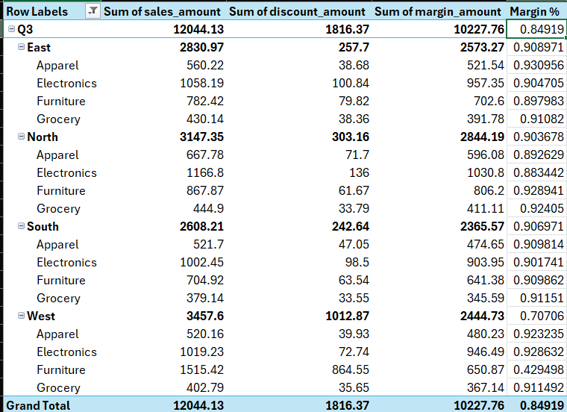

West + Furniture is dramatically different.
Furniture accounts for:
- 1,515.42 sales
- 864.55 discounts
- 650.87 margin
- Only 42.95% margin
Compare that with the other West categories, all around 91–93% margin.
And here's the really important evidence:
West's total discount = 1,012.87
West Furniture discount = 864.55
So West Furniture alone contributes approximately 85% of all West's Q3 discounts.
That explains why West was the regional outlier.

Case-file entry
View 3 — Q3 + West category drill-down: Drilling down from West into category identified Furniture as the extreme outlier. West Furniture generated 1,515.42 in sales but incurred 864.55 in discounts, leaving only 650.87 in margin, a 42.95% margin rate. The other West categories had margin rates above 91%. West Furniture therefore became the primary suspect.
OLAP operation: Drill-down.

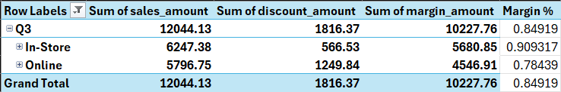

The totals are still the full Q3 totals:
- Sales = 12,044.13
- Discount = 1,816.37
- Margin = 10,227.76

Q3 channel pivot: Online had a substantially lower margin rate than In-Store (78.44% vs. 90.93%), suggesting Online was associated with the discount problem. However, this view was not sufficiently sliced to identify the exact region/category combination.

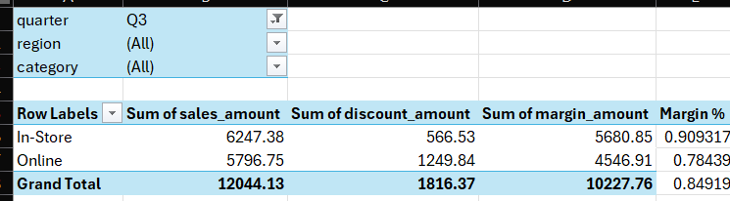

Previous channel result already tells us Online is suspicious, because Q3 Online margin was only 78.44% versus 90.93% In-Store.
But we cannot yet say the exact culprit is West + Q3 + Furniture + Online until we see the channel split within West Furniture.

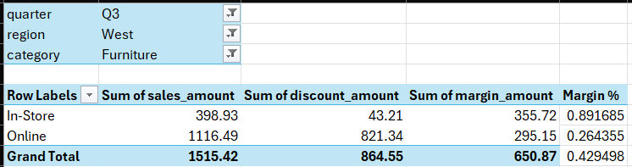

The culprit
WEST + Q3 + FURNITURE + ONLINE
The number that proves it is:
$821.34 discount on $1,116.49 of sales = 73.56% discount rate, leaving only $295.15 margin (26.44%).
Check the arithmetic:
1,116.49 − 821.34 = 295.15
Compare that with West Furniture In-Store:
398.93 − 43.21 = 355.72
So despite Online having almost 3× the sales of In-Store, it produces less margin dollars because of the enormous discount.

Complete OLAP trail
Use this sequence in your submission:
- Roll-up — Quarter
  - Q3 sales: 12,044.13
  - Q3 discount: 1,816.37
  - Q3 margin rate: 84.92%
  - Q3 discounting was substantially worse than the other quarters.
- Slice — Q3 → Region
  - West margin rate: 70.71%
  - Other regions: approximately 90–91%
  - West had 1,012.87 of Q3's 1,816.37 discounts.
- Drill-down — West → Category
  - West Furniture margin rate: 42.95%
  - West Apparel: 92.32%
  - West Electronics: 92.86%
  - West Grocery: 91.15%
  - Furniture was the obvious outlier.
  - Furniture generated 864.55 of West's 1,012.87 discounts.
- Drill-down — Furniture → Channel
  - In-Store margin: 89.17%
  - Online margin: 26.44%
  - Online discount: 821.34
- Dice — Exact combination
  - Region = West
  - Quarter = Q3
  - Category = Furniture
  - Channel = Online
- Pivot — Confirmation
  - Reorienting the dimensions by channel exposes Online Furniture in West as the extreme outlier.

